# Step 1: Launch an EC2 Instance

## Log in to AWS Management Console:

* + Go to the AWS Management Console at https://aws.amazon.com/console/
  + Sign in with your AWS credentials.

## Navigate to EC2 Dashboard:

* + In the AWS Management Console, type "EC2" in the search bar and select EC2 to navigate to the EC2 Dashboard.

## Launch an Instance:

* + Click on the "Launch Instance" button.



* + Choose an Amazon Machine Image (AMI): Select "Ubuntu Server 20.04 LTS (HVM), SSD Volume Type".

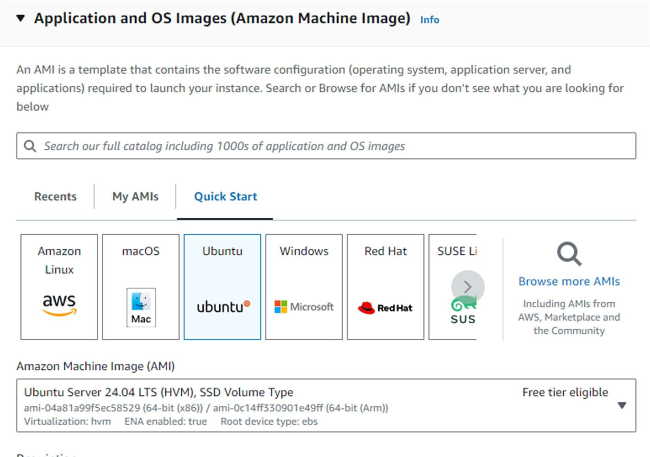

* + Choose an Instance Type: Select t2.micro (eligible for the free tier).

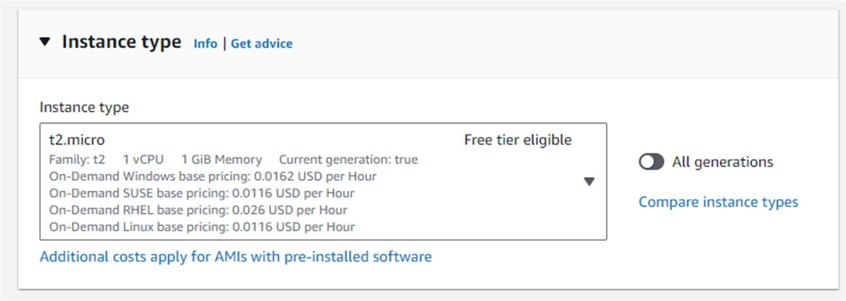

* + Configure Instance:
    - Select an existing key pair or create a new one.
    - Network: Choose the default VPC.
    - Subnet: Choose a subnet in the US-East-1 (N. Virginia) region.
    - Enable Auto-assign Public IP.

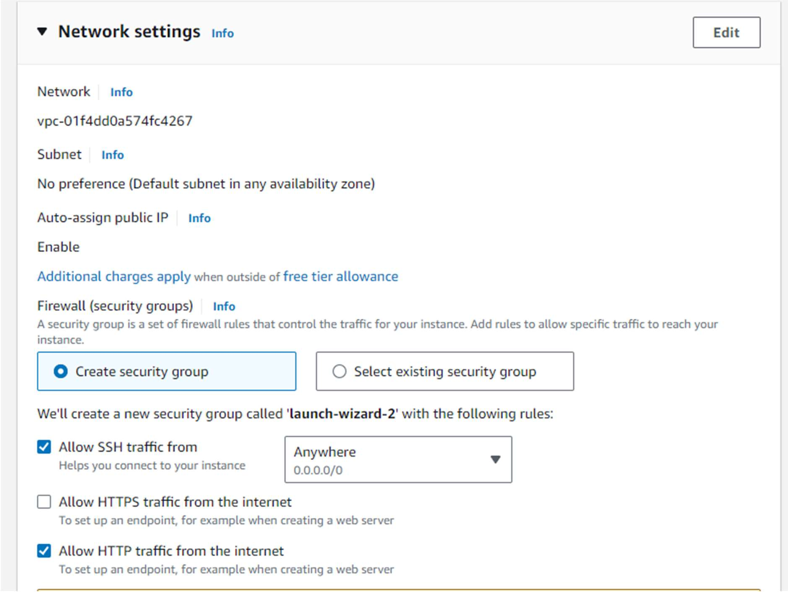

* + Add Storage: Keep the default settings.
  + Add Tags: Add a tag to identify your instance (e.g., Key: Name, Value: Nginx).

## Review and Launch:

* + Review your instance settings and click "Launch".

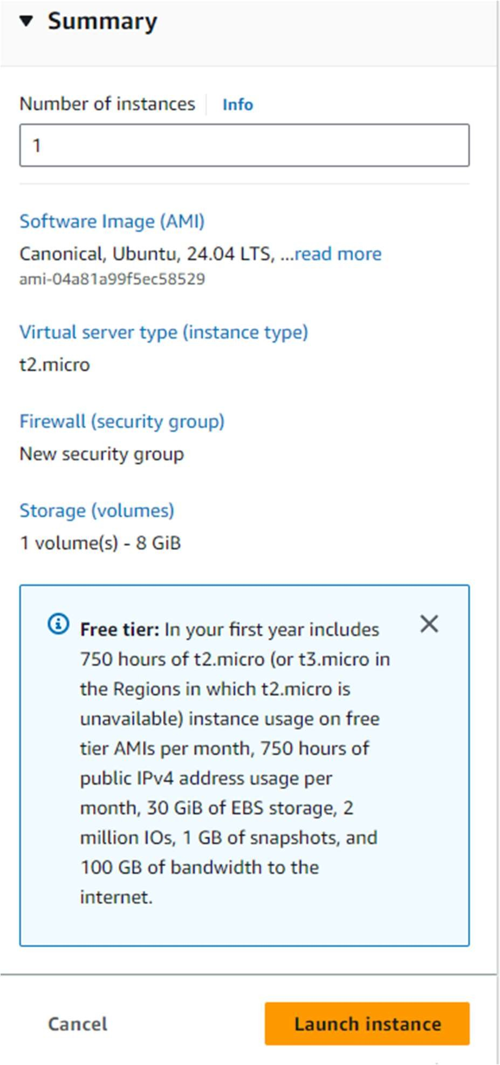



## Configure Security Group:

* + Add a new security group with the following rules:
    - Type: HTTP, Protocol: TCP, Port Range: 80, Source: 0.0.0.0/0
    - Type: SSH, Protocol: TCP, Port Range: 22, Source: 0.0.0.0/0

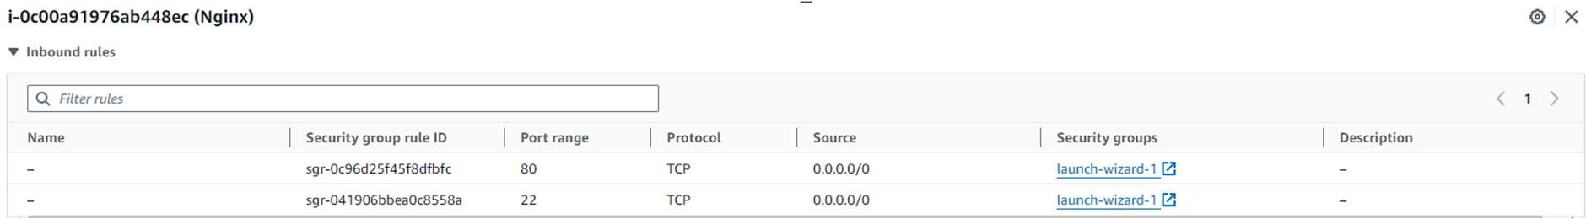

# Step 2: Connect to Your Instance

## Connect to the EC2 Instance:

* + In the EC2 Dashboard, select your instance.
  + Click on "Connect" and follow the instructions to connect to your instance using SSH.

# Step 3: Install Nginx

## Update Package List:

sudo apt update

## Install Nginx:

sudo apt install nginx -y

## Start and Enable Nginx:

sudo systemctl start nginx sudo systemctl enable nginx sudo systemctl status nginx

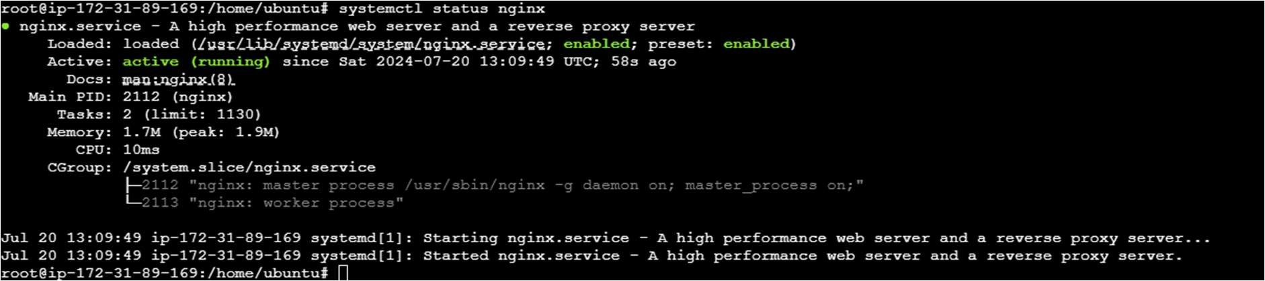

# Step 4: Configure Nginx to Display "Hello World"

## Modify the Default Nginx Webpage:

* + Open the default Nginx configuration file:

sudo nano /var/www/html/index.nginx-debian.html

* + Replace the content with the following HTML:

<!DOCTYPE html>

<html>

<head>

<title>Welcome to Nginx!</title>

</head>

<body>

<h1>Hello World</h1>

</body>

</html>

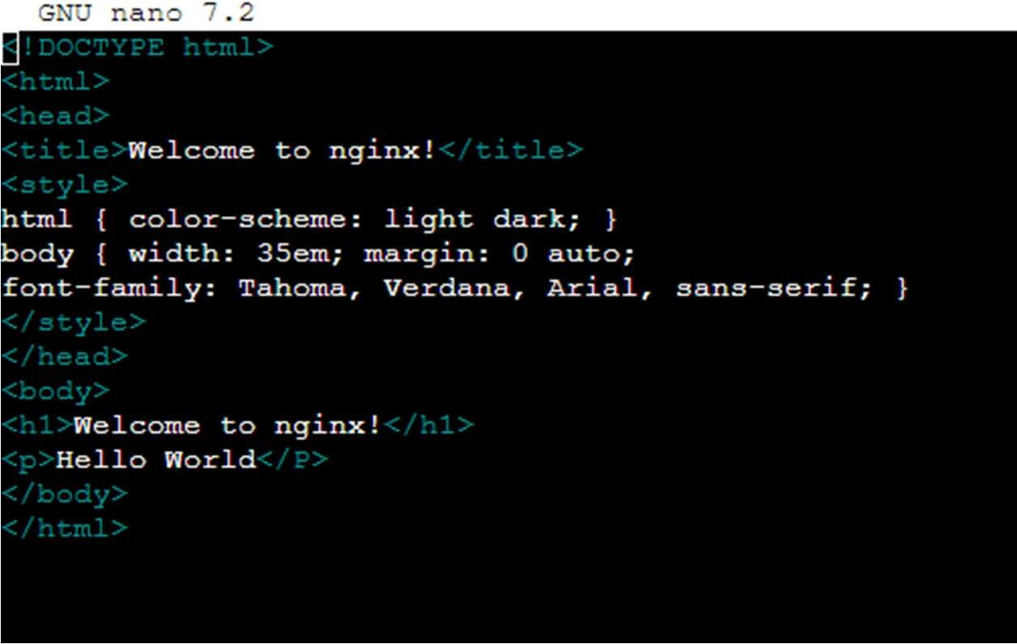

## Save and Close the File:

* + Press Ctrl + X to close the file.
  + Press Y to confirm changes, then press Enter.

# Step 5: Verify the Configuration

## Open a Web Browser:

* + Enter the public IP address of your EC2 instance in the address bar.
  + You should see a webpage displaying the message: "Hello World".

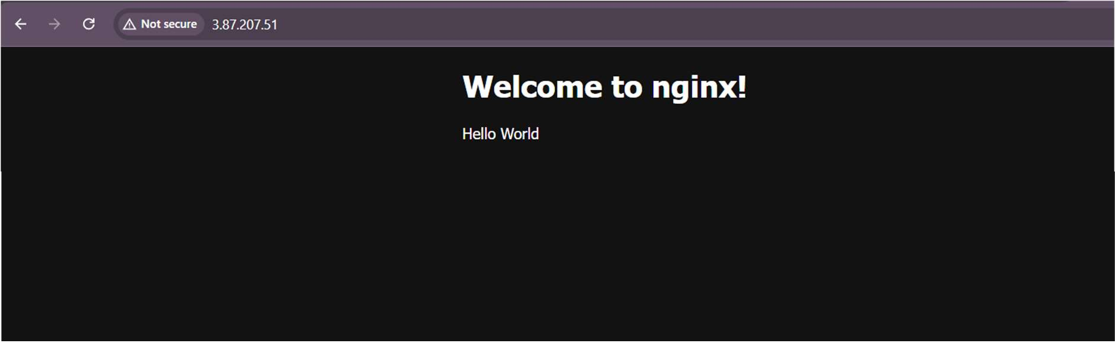

# Step 6: Stop the EC2 Instance

1. **Stop the EC2 Instance**:
   * In the EC2 Dashboard, select your instance.
   * Click on "Instance State" and then "Stop Instance".
   * Confirm the action.

# Step 7: Create and Attach an EBS Volume

1. **Create an EBS Volume**:
   * In the AWS Management Console, go to the EC2 Dashboard.
   * In the left-hand menu, under "Elastic Block Store", click "Volumes".

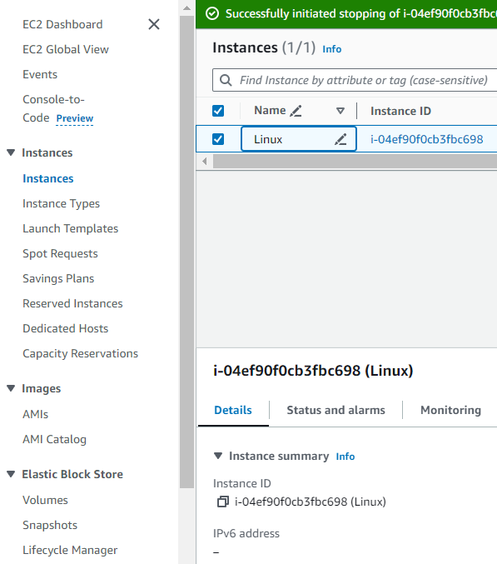

* + Click on the "Create Volume" button.



* + Configure the volume:
    - Size: 20 GiB.
    - Availability Zone: Select the same availability zone as your EC2 instance.
  + Click "Create Volume".

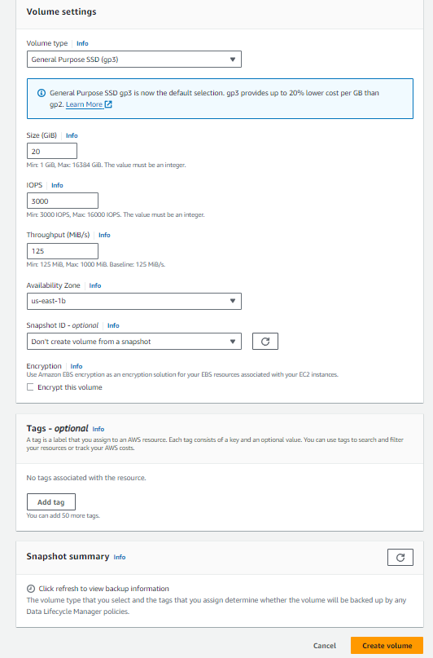

1. **Attach the EBS Volume to the EC2 Instance**:
   * After the volume is created, select it from the Volumes list.
   * 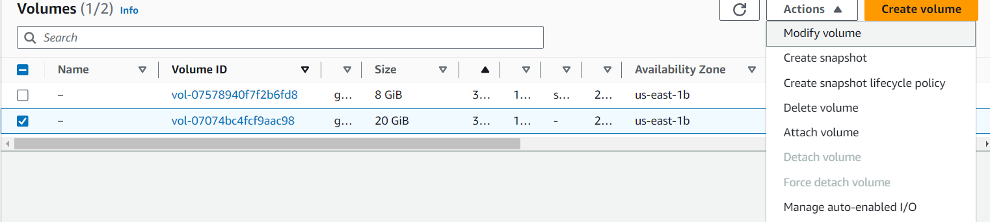Click on "Actions" and select "Attach Volume".
   * Choose the instance you stopped earlier from the "Instance" dropdown menu.
   * For "Device", you can use the default value (e.g., /dev/sdf).
   * 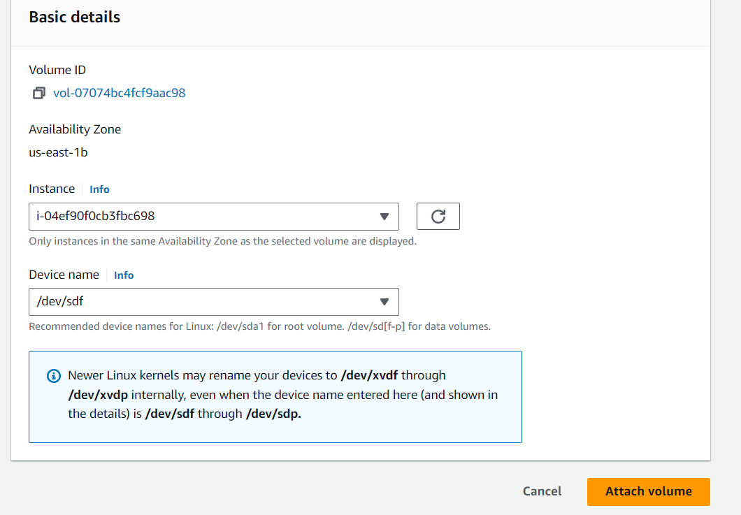Click "Attach".

**Step 8: Start the EC2 Instance and Ensure the New Size Reflects**

1. **Start the EC2 Instance**:
   * In the EC2 Dashboard, select your instance.
   * Click on "Instance State" and then "Start Instance".
   * Wait for the instance to be in the "running" state.
2. **Connect to Your EC2 Instance**:
   * In the EC2 Dashboard, select your instance.
   * Click on "Connect" and follow the instructions to connect to your instance using SSH.
3. **Check the Attached Volume**:
   * Run the following command to check the attached volume:

lsblk

* + You should see the volume listed (e.g., /dev/xvdf).

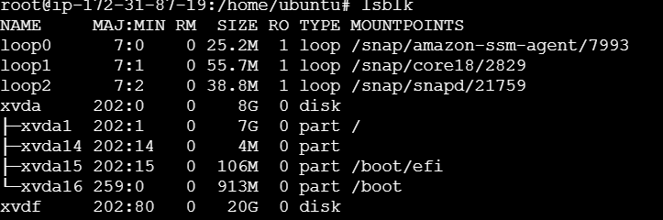

**Step 9: Resize the Attached Volume Using AWS Management Console**

1. **Resize the EBS Volume**:
   * In the EC2 Dashboard, select "Volumes" under "Elastic Block Store".
   * Select the volume you attached and click on "Actions" -> "Modify Volume".

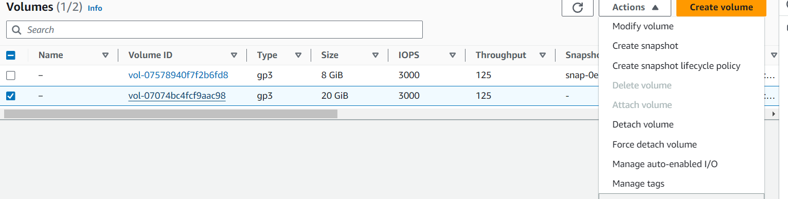

* + Change the size to a larger value (e.g., 30 GiB) and click "Modify".
  + Confirm the modification in the pop-up dialog.

**Step 10: Start the EC2 Instance and Ensure the New Size Reflects**

1. **Start the EC2 Instance**:
   * In the EC2 Dashboard, select your instance.
   * Click on "Instance State" and then "Start Instance".
   * Wait for the instance to be in the "running" state.
2. **Connect to Your EC2 Instance**:
   * In the EC2 Dashboard, select your instance.
   * Click on "Connect" and follow the instructions to connect to your instance using SSH.
3. **Check the Attached Volume**:
   * Run the following command to check the attached volume:

Lsblk

* + You should see the volume listed (e.g., /dev/xvdf).

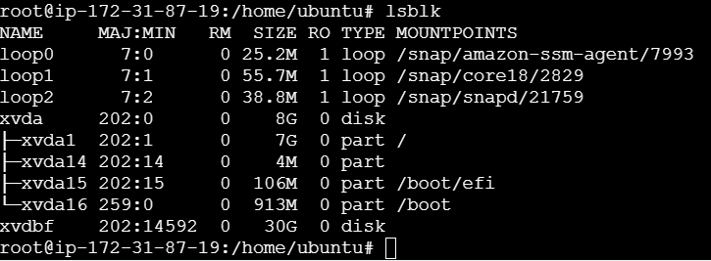

**Conclusion**

By following this project guide, you have successfully launched an EC2 instance, created and attached an EBS volume, resized the volume, and ensured the new size is reflected in the EC2 instance. This hands-on experience demonstrates the practical skills required for managing EC2 instances and EBS volumes in AWS.

**Additional Resources**

* [AWS EC2 Documentation](https://docs.aws.amazon.com/ec2/index.html)
* [AWS EBS Documentation](https://docs.aws.amazon.com/ebs/index.html)
* [Ubuntu Server Documentation](https://ubuntu.com/server/docs)